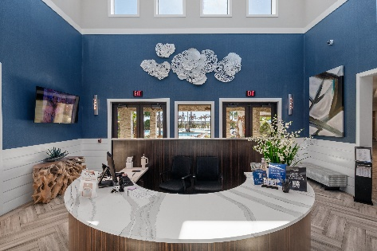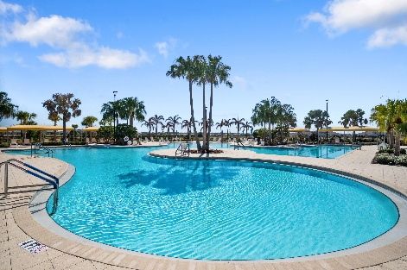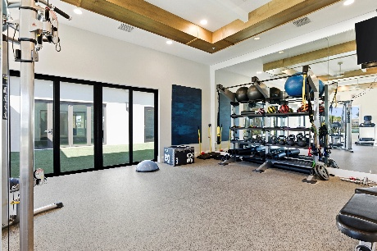

Medley at Mirada Resort: A Private Resort Experience Designed for Everyday Living

Medley at Mirada, an active adult lifestyle community offering a dedicated resort environment created for connection, wellness, and an active lifestyle. Residents enjoy exclusive access to a private clubhouse and amenity campus, along with full privileges to the renowned Mirada Lagoon and coming soon, exclusive to Medley at Mirada residents. Enjoy exclusive access to a beautifully designed resort-style amenity area offering a covered tiki pavilion, outdoor bar, putting green, bocce ball courts, firepits, shaded seating and gathering spaces, a clubhouse, and convenient on-site restrooms.

The Medley Resort & Clubhouse is located at 31800 Cannon Rush Dr, San Antonio, FL 33576

A beautifully designed social hub where residents gather, relax, and stay active.

Features include:
- Grand reception and welcome center
- Full-service restaurant, social lounge and bar area
- Event and gathering space for community functions with dance floor and stage
- Card rooms and hobby spaces
- Billiards and games
- Lifestyle director coordinating daily and weekly activities
- Large-screen TVs and comfortable conversation seating
- Fitness center and an additional Exercise Studio
- Resident lounge with complimentary daily coffee and tea
- Dog grooming spa

Lifestyle programming includes:
- Fitness and wellness classes
- Yoga, strength, and low-impact training
- Social clubs and special interest groups
- Happy hours, live entertainment, and themed events
- Holiday celebrations and community mixers

Resort-Style Outdoor Amenities:
- Resort pool with lap lanes and expansive sun deck, zero entry
- Heated spa
- Covered cabanas and shaded seating areas
- Outdoor gathering and event spaces
- Full outdoor bar with food
- Scenic walking and biking paths
- Outdoor propane fire pits

Sports and Recreation Complex:
- Multiple pickleball courts
- Tennis courts
- Bocce ball & shuffleboard courts
- Open lawn space for games and activities
- Designated golf cart parking

Exclusive Access to the Mirada Crystal Lagoon
Residents also enjoy full access to the community’s signature waterfront experience.
- White sand beach areas
- Swimming and floating zones
- Kayaks and paddleboards
- Lagoon-side food and beverage service
- Private cabanas and shaded seating
- Resident events and seasonal programming

***COMING VERY SOON***

Medley Tiki Pavilion and Putting Green exclusive for Medley at Mirada residents only.

An exciting new addition that will expand outdoor social and recreational opportunities.

Planned features include:
- Covered tiki-style gathering pavilion
- Outdoor bar and social area
- Putt-putt style putting green
- Additional shaded seating and lounge spaces
- Dedicated space for games, social hours, and community events
- Boardwalk that leads directly to Medley’s private beach

This exciting addition enhances the Medley lifestyle by creating another everyday gathering destination within the community’s amenity collection. Be sure to tour all the exceptional amenities available. You will not be disappointed.

