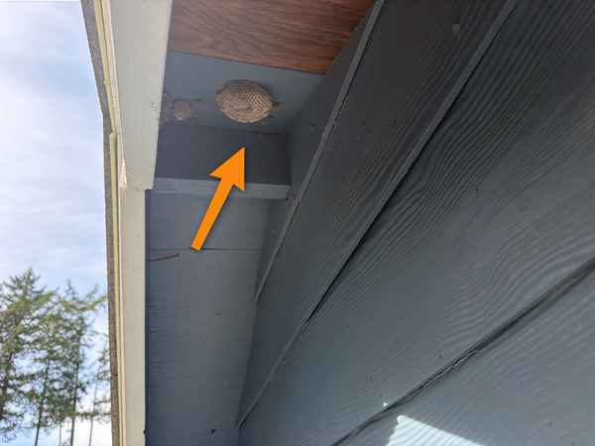
4.26.1 – Pests. Two wasp/hornet nests were removed when the roof was cleaned.
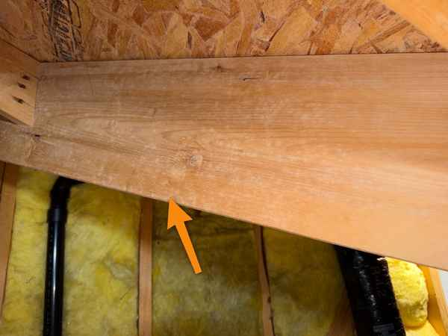
5.10.1/7.4.1 - Mold-like growth. This is old on dry wood, and the cause was rectified when the roof was re-done and is documented in pictures by Patriot Roofing. The surface was wiped clean with bleach.
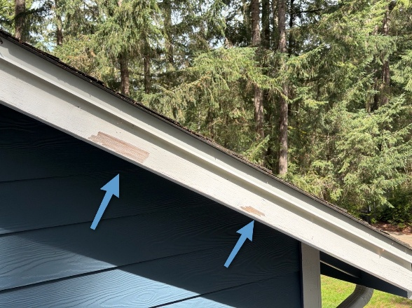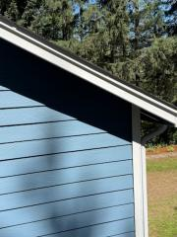
4.7.1 – Exterior Trim Paint. Trim was scraped and repainted.
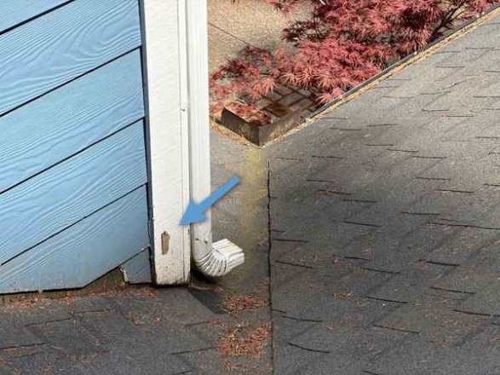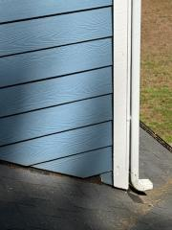
4.7.1 – Exterior Trim Paint. Trim was scraped and repainted
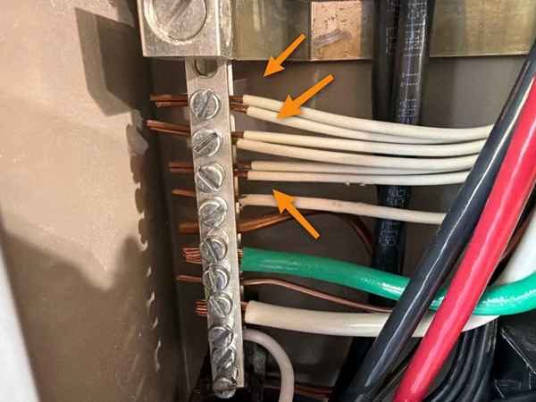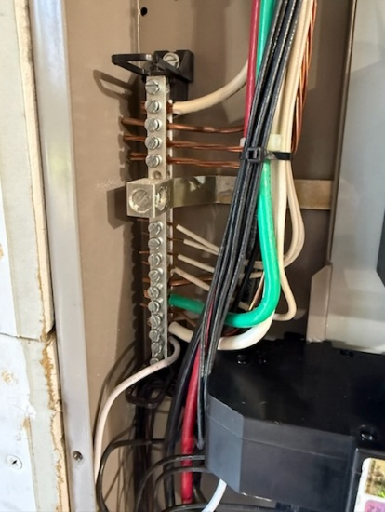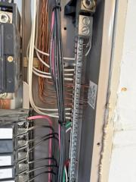
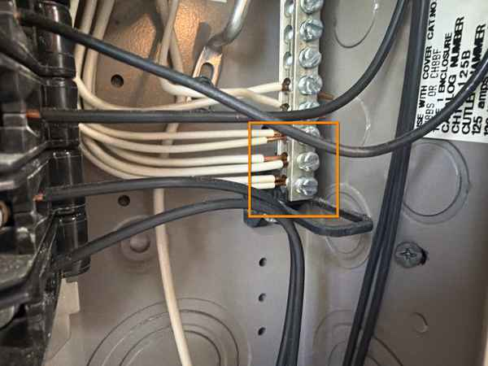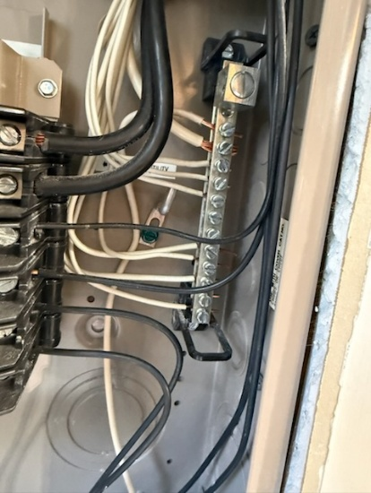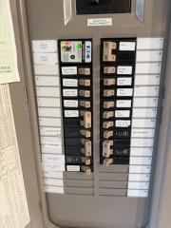
11.6.1 – Multiple neutrals under one lug. This was repaired by a licensed electrician. Surge Protection was moved to the top of the panel, and the panel was re-labeled.
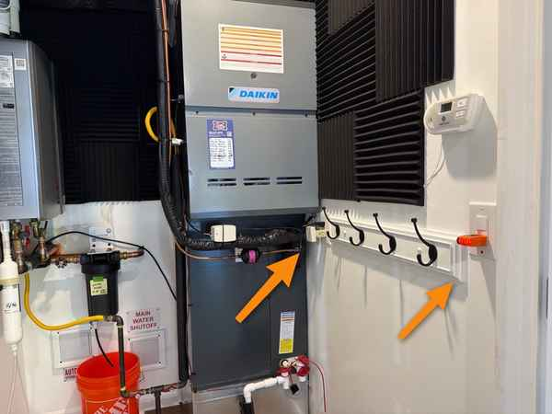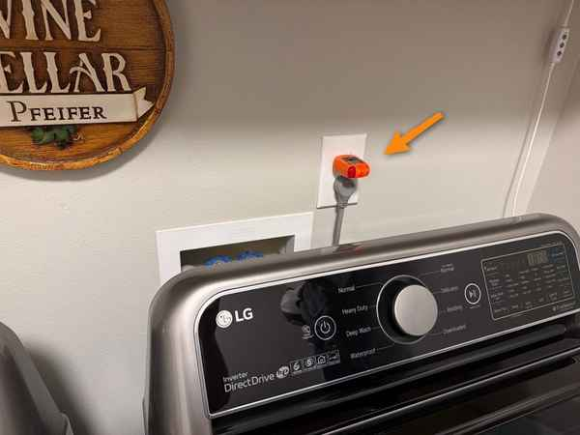
11.9.1 – Receptacles: GFCI. Per a licensed electrician, a GFCI is not required in the Mechanical Room. GFCI outlets were not required in these areas when the home was built (Grandfathered).
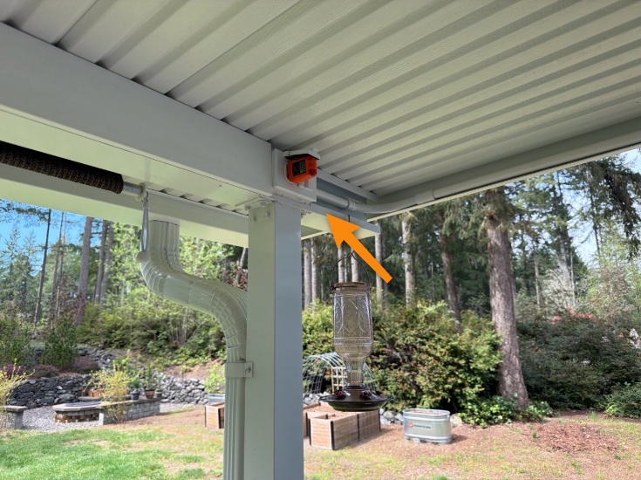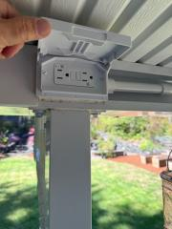
11.9.2 – Receptacles (Exterior) GFCI. Exterior outlet was replaced with a GFCI.

.

